Geometric Mean Name: ___________________________ pd: _____

Find the Geometric Mean between:

|  |  |  |  |  |  |  |  |  |  |  |  |
| --- | --- | --- | --- | --- | --- | --- | --- | --- | --- | --- | --- |
| 1. | 5 and 20 |  | 2. | 64 and 49 |  | 3. | 1 and 3 |  | 4. | 100 and 6 |  |
|  |  |  |  |  |  |  |  |  |  |  |  |
| 5. | 2 and 18 |  | 6. | 3 and 27 |  | 7. | 8 and 20 |  | 8. | 5 and 10 |  |

9-16: Refer to diagram

L

J

M

K

9. If LM = 4 and MK = 8, find JM ________________

10. If LM = 6 and JM = 4, find MK________________

11. If JM = 3 and MK = 6, find LM________________

12. If JM = 4 and JK = 9, find LK________________

13. If JM = 3 and MK = 9, Find LJ________________

14. If JM = 3 and JL = 6, find MK________________

15. If JL = 9 and JM = 6, find MK________________

16. If LK = 7 and MK = 6, find JM________________

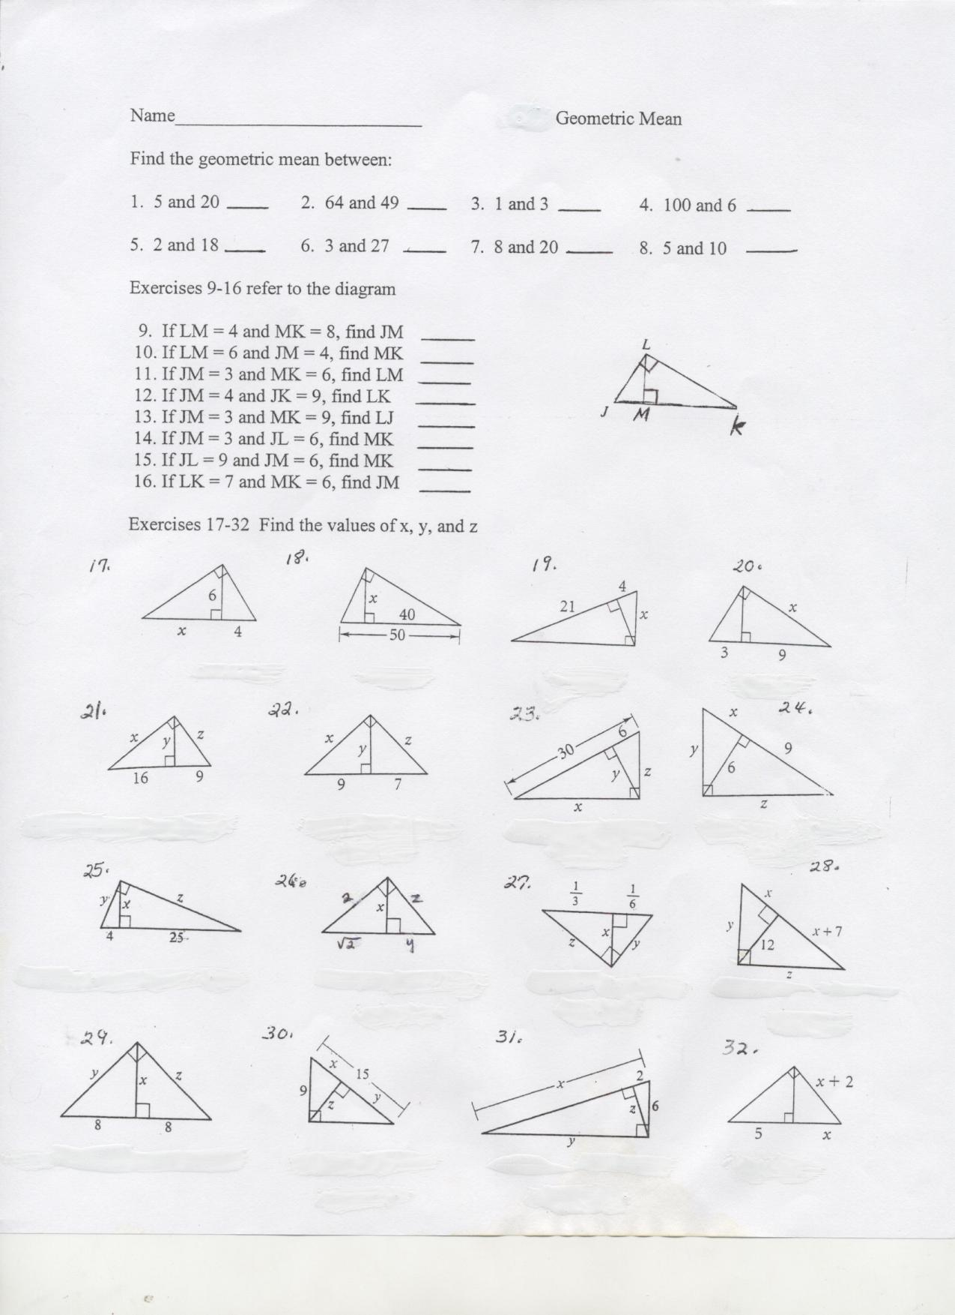17 – 32: Find the values of x, y, & z



